

**Smart Energy Monitoring Application**

# Shanmugam Mithra

Computer Science & Engineering, Panimalar Engineering College

Anna University, Chennai

Chennai, India



# Sangavi Priyaa.M

Computer Science & Engineering, Panimalar Engineering College

Anna University, Chennai Chennai, India

# Preethi.S

Computer Science & Engineering, Panimalar Engineering College

Anna University, Chennai Chennai, India

# Dr L.Jaba Sheela

Computer Science & Engineering, Panimalar Engineering College

Anna University, Chennai Chennai, India

***Abstract*—** The Internet of Things (IoT) is revolutionizing Industries faster than ever. IOT consists of a network of physical objects or things embedded with electronics, sensors, software, and network connectivity. Objects can collect and exchange data using this technology. In this project, we will be developing a system that will automatically monitor all the currently operating appliances in a building. This system can generate alerts or take intelligent decisions using the concept of IOT. You can update real-time data into the cloud server. IOT has given us a promising way to build powerful industrial systems and applications by using Wi-Fi devices, LTE modems, smart relay switches and sensors. The main contribution of the project is that it summarizes the uses of IOT in organizations like colleges or schools. It also shows how we can use Artificial Intelligence to monitor and control the appliance thus increasing productivity and reducing expenses. Our system uses a microcontroller for processing all user commands and an EEPROM chip to save data. Digital Voltmeter, Ammeter, and Wattmeter can be attached to the IOT device without any additional circuits which reduce cost. A Wi-Fi router and modem are linked to the IOT module to update each machine status. An appliance can receive user commands over Internet Protocol. On sending commands from mobile through the internet, it will be received by the modem linked with the IOT circuit. The modem decodes the information. This information is then passed to the microcontroller for further processing. We can get real-time data of the power consumed by the appliance. We can extract data stored in the chip by importing it into an MS Excel file. The chip can store data for up to three months. The hardware components and technology used in this idea are affordable, easily available, and replicable. The experimental results highlight the significance of this project and validate this concept.

**Keywords**— Internet Of Things, Artificial Intelligence, Monitor, Increase productivity, Reduce expenses

## Introduction

Everyone owns a phone these days and viewing data from a mobile phone from anywhere through an application is very convenient for everyone. A person that owns a large institution or organization will find it difficult to monitor all the buildings. These people will be paying a lot of money every month just for their current bills. It is important to use technology for them to identify which building consumes more current so that they can make changes accordingly to save energy and money. It is possible to view real-time data using a mobile application to make changes to your organization to save energy using this project. We can see if any appliances are still in use in non-operating hours.

1. **LITERATURE SURVEY**

### *Smart energy efficient home automation system using IOT*

**Year: 2019**

**Authors:** Satyendra K. Vishwakarma, Prashant

Upadhyaya, Babita Kumari, Arun Kumar Mishra

## Advantages:

* The advantage of Google assistance and web-based application can help control the appliance of the

system.

* This model is designed to provide better flexibility and makes the system robust.

## Disadvantages:

* There is no EEPROM chip used to store critical machine data’s during power failures.
* Instead of wifi, Bluetooth technology is used which leads to the limited device controlling distance.
* It can just only Turn-On or Turn-OFF devices. No option is given to view the current machine status over the internet.

### *A step towards Home Automation using IOT*

**Year:** 2019

***Authors:*** *Harsh Kumar Singh; Shashank Pal; Kavita Pandey; Saurabh Verma;*

## Advantages:

* The microcontroller is used together with relays to control electrical switches remotely from the server.
* User can control switches with the help of a Web Application after authentication.
* Implementation of an automation system with Z-wave is less complicated and has a greater range than the

automation system implemented with ZigBee.

## Disadvantages:



* No protection circuit added to connected devices to prevent voltage spikes
* No MOSFET used for fast switching and endurance
* This device can control only the home appliance.
* It is incompatible with sensitive devices

### *Smart home automation using IOT based sensing and monitoring platform*

**Year:** 2019

**Authors:** Majid Al-Kuwari, Abdulrhman Ramadan, Adel Gastli, Yousef Ismael, Laith Al-Sughair

## Advantages:

* Sense different variables inside the house using the microcontroller board.
* Real-time data sensing, processing and uploading or downloading from the cloud server
* Monitor these parameters using a system which will help to maintain the parameters within an acceptable

range.

* Automation is accomplished using the Internet of Things (IOT).
* This gives accesses to certain data in the house even when you are not physically present there.
* It gives the ability to control some parameters remotely.

## Disadvantages:

* Can be used for monitoring small homes only. Not suitable for large buildings.
* No secure authentication when controlling via the internet.
* Microcontroller functions cannot be reprogrammed for adding additional functions from an Android application.

### *Self-Commissioning Industrial IoT-Systems in Process Automation: Reference Architecture*

**Year:** 2018

**Authors:** *Heiko Koziolek; Andreas Burger;Jens Doppelhamer*

## Advantages:

* PnP in IoT systems can reduce industrial device commissioning times across vendor products to a few

seconds.

* This system can handle more than 500 signals per millisecond during runtime.
* This is sufficient for most application scenarios.

## Disadvantages:

* Since cable is used as an interface between the IOT chip and Controller. Every time we need to plug in the cable for making any changes in coding.
* Devices can be controlled using a laptop only. No provision is given for controlling devices via android

mobiles

* Cannot deal with simultaneous Real-time monitoring of the machines and data upload to cloud server

### *Enhanced home automation system using Internet of Things*

**Year:** 2017

***Authors:*** *S.L.S. Sri Harsha; S. Chakrapani Reddy; S. Prince Mary*

## Advantages:

* To make the application more user-friendly, a smart energy efficient home automation system is proposed.
* It can access and control the home equipment from every corner of the world.
* Internet connectivity module is attached to the main supply unit of the home system that can be accessed through the Internet.

## Disadvantages:

* Complex wiring method used which leads to more maintenance if any wiring fault occurs
* Unable to export data’s to other devices for Report generation.
* Since this is not an IP ready device, the latest sensors, IP cameras cannot be embedded to the same IOT

device

## METHODOLOGY

This system makes sure that we can view the current consumption patterns of any institution, building or office from anywhere. We can view in real-time which building in an organization is consuming the most power. The real-time data is presented in pictorial representation for easy analysis. We can view the real-time data using this project. This will help us to save money as well as energy.

We will be creating an application and will be using IOT to connect this application with our hardware device. The hardware device that we will be creating will contain the ammeter, voltmeter and wattmeter to measure the amount of current flowing through. This data will be sent to the application on our mobile phone.

1. **IMPLEMENTATION**
   1. Module I- Power Consumption Recorder
      * PCR is Power Consumption Recorder. In the PCR module, entire power details are displayed in Kwh.
      * This module is used to avoid data loss during power cut these entire records are synchronized to an EEPROM chip/SD card mounted to the microcontroller board.
      * In PCR module Power consumed by every device and overall industry power, peak hour power consumption is monitored and stored as data logs

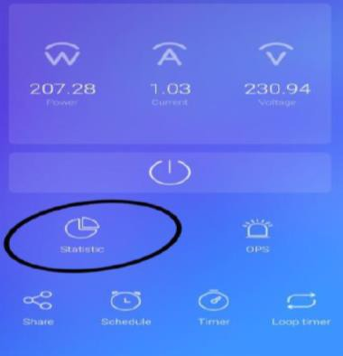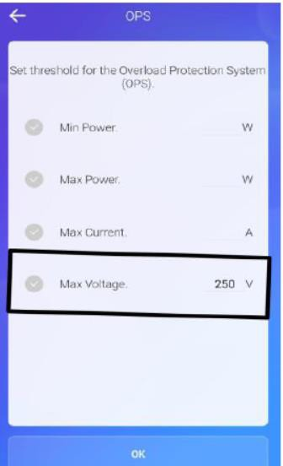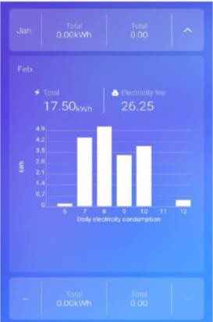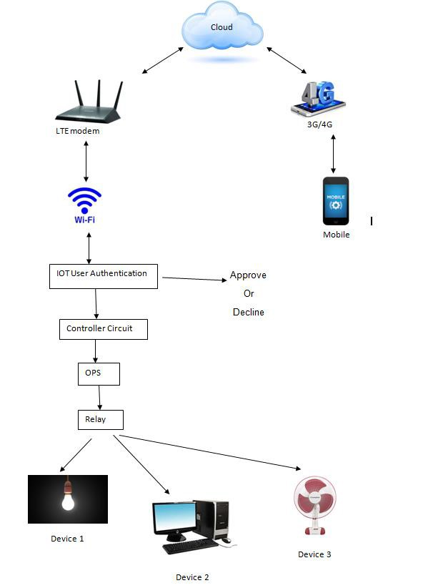

* + - Import recorded data into android mobiles over Wi-Fi or 4G network. The data will be saved to

download folder in .csv file which can be opened using MS Excel for detailed analysis and can be exported for report generation.

d. System Architecture Diagram

* 1. Module II- Overload Production Service
     + This module is to protect the loads. Maximum current, maximum power and minimum power values
     + It can be set here to protect the loads as the relay switches according to the value set.
     + OPS module executes its function before operating the relays. In the OPS module, the safety limit for the running machinery can be set.
     + If any sudden overvoltage comes into the power line, this module sends an immediate command to IOT main board relays to shut down the plant likewise safety amps and safety power threshold can be set.
  2. Module III- Real-Time Statistics
     + Monitor current, voltage and power for appliances

## V. RESULTS

The proposed system is suitable for the monitoring of current consumption, voltage and power consumption. It provides a better way to access the Real-Time data by viewing into the application. It allows storing and access to data from anywhere at any time that relates to energy monitoring. This paper has introduced the method to view which building consumes the most power so that we can save energy. This system saves money that you spend on paying current bills. All these objectives are satisfied with the project.

## Hardware Component:

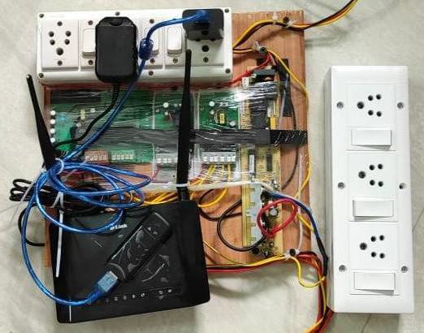

1. **CONCLUSION**

This proposed system thus helps us to easily monitor the energy by a single application which becomes more convenient in the future world of digital India and all over the world. It reduces energy consumption and also detects an abnormality in consumption. It is a better way to optimize cost. Get real-time energy insights. It reduces manpower which also reduces operational costs. Helps in boosting the facility of performance and predicts future energy needs.

## FUTURE ENHANCEMENTS

Implement an automated timing system which helps in turning the whole system on and off at the allocated time. We can add a camera into the system, as the hardware part already has the capacity to support the camera in it. This future enhancement allows us to view the capturing of live video from the same mobile application. This application has the capability to view energy monitoring of various buildings located in various cities through the same mobile application.

## REFERENCES

[1] Marco Casini, “Internet of things for energy efficiency of buildings,” International Scientific Journal Architecture and Engineering. – 2013

[2] Shu-ping Le, Hong Zeng, Jian Qiu, Song Zhang “Design and implementation of wireless power monitoring system for public buildings” - 2013 (IEEE Paper)

[3] S. Kumar and S. R. Lee, "Android-based smart home system with control via bluetooth and internet connectivity," The 18th IEEE International Symposium on Consumer Electronics (ISCE 2014), Jeju Island, 2014, pp. 1-2.

[4] Heiko Koziolek; Andreas Burger; Jens Doppelhamer, “Self-Commissioning Industrial IoT-Systems in Process Automation: Reference Architecture” – 2018 (IEEE Paper)

[5]Satyendra K.Vishwakarma, Prashant Upadhyaya, Babita Kumari Arun Kumar Mishra,” Smart Energy Efficient Home Automation System Using IoT” -2019 (IEEE Paper)

[6] S.L.S. Sri Harsha; S. Chakrapani Reddy; S. Prince Mary, “Enhanced Home Automation System using Internet of Things”

2017 (IEEE Paper)

[7] Harsh Kumar Singh; Saurabh Verma; Shashank Pal; KavitaPandey,” A step towards Home Automation using IOT”

2019(IEEE Paper)

[8] Majid Al-Kuwari, Abdulrhman Ramadan, Yousef Ismael, Laith Al-Sughair, Adel Gastli,” smart-home automation using IOT-based sensing and monitoring platform”-2019(IEEE Paper)

[9] Sheela, L. J., R. Hemamalini, and M. Rejendran. "Cell phone the primary personal mobile computing devices." International Journal of Computer Trends and Technology 1.2 (2011): 87-90